11 PHYSICS ATAR
ASSIGNMENT 3: NEWTON'S LAWS, WORK AND ENERGY

NAME: DUE DATE: TOTAL: 

1. Bulk carriers are used extensively to move large amounts of iron ore around the world. Typically the
mass of such behemoths is around 200,000 tonnes (fully loaded). It is important that the engines of
these carriers are turned off well out to sea as they approach port.

Giving mention to the Physics principles involved, explain why this method is employed when these
carriers enter port.

(4)

2. During a tennis game, a player hits the ball at 40.0 ms⁻¹ (horizontal velocity) directly towards her opponent who
hits it straight back at 57.0 ms⁻¹. The 55.0 g ball is in contact with the racquet for 0.115 s.

(a) Determine the change in velocity of the ball.

(3)
(b) What force is exerted by the racquet onto the ball?

(2)

(c) What impulse is acting?

(2)

(d) How would you expect the force exerted to change if a racquet with "loose strings" (rather than
"tight strings") was used? Explain your answer using the Physics principles involved.

(3)
3. A child of mass 25.0 kg slides down a playground slide from rest in 3.20 s. The force acting down the
slide is 125 N and a frictional force of 35.0 N acts against the child.

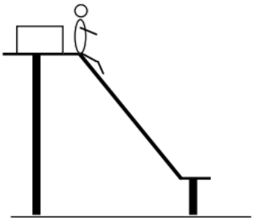
(a) Calculate the acceleration of the child down the slope.

(3)

(b) Determine the velocity of the child at the bottom of the slide.

(2)

4. An archer fires an arrow (of mass 96.0 g) with a velocity of 1.20 x 10² ms⁻¹ into a target (of mass 1.50 kg)
hanging by two light pieces of string from the branch of a tree.

(a) If the arrow embeds into the target, what is the velocity of the target immediately after impact?

(3)
(b) How high (vertically) does the target and arrow swing?
(HINT: Consider the conservation of energy.)

(3)

(c) In reality, will the target and arrow swing this high? Explain your answer in terms of the Physics'
principles involved.

(3)

5. On a building site in Perth, a crane lifts a 1.00 tonne cradle full of 4.00 tonnes of cement off the ground
to take it up to the 25th floor. It accelerates upwards from the ground at 1.50 ms⁻² for 4.00 s before
maintaining its speed up to the 20th floor. It then decelerates uniformly to a stop at the 25th floor.
The total time taken from the ground is 17.4 s.

(a) Compare the tension in the single cable holding the cradle when it is
accelerating upwards and when it has constant speed.
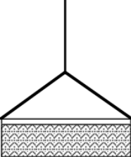

(5)

(b) Estimate the work done by the crane motor in lifting the cradle up to the 25th floor.

(3)
(c) Estimate the average power expended by the motor.

(2)

